**I. Learning Objectives**

* **Recognize** spoken and written language related to people, feelings, and body parts.
* **Produce** oral and written messages about people, feelings, and body parts using appropriate grammatical structures.
* **Interact** with peers showing empathy and respect, valuing bodily and emotional diversity.

**II. Module Outline**

| **Unit** | **Main Topic** | **Grammar & Vocabulary** | **Hours** |
| --- | --- | --- | --- |
| 1 | People | Nouns (people), Yes/No questions | 12 |
| 2 | Feelings | Feeling adjectives, Wh‑questions (“what,” “why,” “how”) | 12 |
| 3 | Body Parts & Body System | Body parts vocabulary, Actions, Hygiene | 12 |
| 4 | Integrative Project | Review and production of oral/written texts | 12 |

**1. PEOPLE**

**A- Vocabulary**

* **Family & Relationships**: cousin, aunt, uncle, grandparents, niece, nephew, partner, roommate
* **Community Helpers**: firefighter, police officer, nurse, librarian, bus driver, mail carrier
* **Personal Descriptions**: tall, short, curly hair, straight hair, glasses, freckles, beard, mustache

**B. Language Chunks & Structures**

* **Describing Appearance**:
  + “She has curly brown hair and green eyes.”
  + “He wears glasses and has a beard.”
* **Talking about Roles**:
  + “My aunt is a nurse at the local hospital.”
  + “Our librarian helps us find interesting books.”
* **Asking & Answering**:
  + “Who lives with you at home?” → “I live with my parents and my younger sister.”
  + “What does your neighbor do?” → “She’s a firefighter.”

**C. Communicative Functions**

* **Introducing & Greeting**: “Hello, I’m Ana. Nice to meet you.”
* **Giving Personal Information**: “I’m from Panama City and I study at Instituto Urracá.”
* **Social Interaction**: “Can you tell me about your best friend?”

**D. Activity Ideas**

* **“People Bingo”**: Each square has a description (e.g. “someone who has a pet cat”). Students circulate asking questions to fill their bingo card.
* **Photo Interview**: Bring magazine cut‑outs of people. In pairs, students “interview” the picture (“What’s her name? What does she do?”).
* 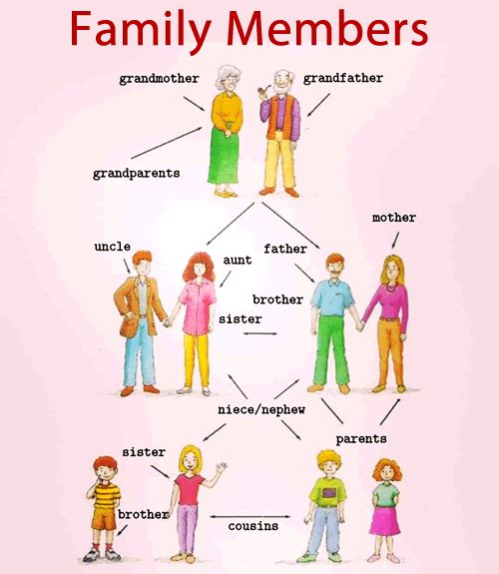**Family Tree Project**: Create a simple family tree poster and write 1–2 sentences about each member.

**2. FEELINGS**

**A. Vocabulary**

* **Subtle Emotions**: worried, jealous, proud, embarrassed, bored, relaxed, nervous, hopeful
* **Intensity Adverbs**: very, quite, a little, extremely, so

**B. Language Chunks & Structures**

* **Expressing Feelings**:
  + “I’m really excited about our trip.”
  + “She feels a bit nervous before exams.”
* **Asking for Reasons**:
  + “Why are you upset?” → “I’m upset because I lost my notebook.”
  + “What makes you proud?” → “Helping my little brother learn to read makes me proud.”
* **Comparing Emotions**:
  + “I’m more tired today than yesterday.”
  + “He’s less angry now.”

**C. Communicative Functions**

* **Checking In**: “How are you feeling this morning?”
* **Offering Support**: “I’m sorry you’re sad. Do you want to talk?”
* **Empathy Phrases**: “That must be hard.” / “I understand how you feel.”

**D. Activity Ideas**

* **Emotion Charades**: Students act out an emotion; others guess.
* **Feelings Thermometer**: Draw a thermometer—students place a marker at their current feeling and explain why.
* **Story Completion**: Give a short story prompt (“Ana got a low grade on her test…”). In groups, students write or role‑play how she feels and what she does next.

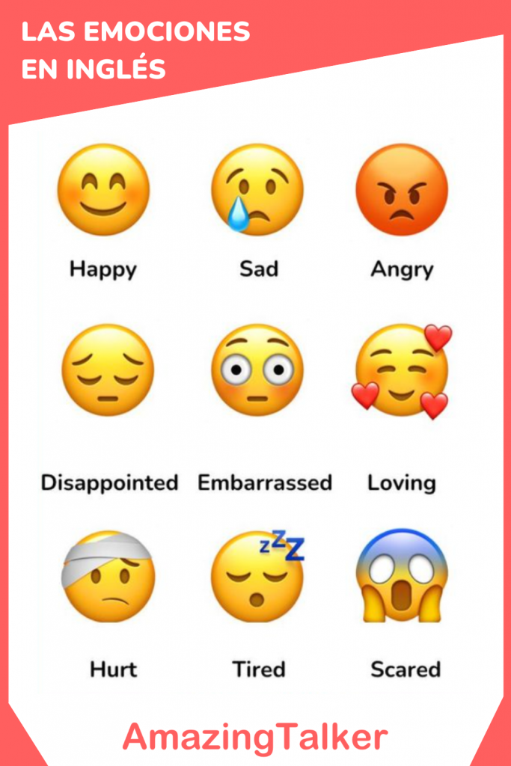

**3. BODY PARTS & BODY SYSTEM**

**A. Vocabulary**

* **Internal Organs**: brain, liver, kidneys, intestines, bladder
* **Senses & Related Verbs**: see (eyes), hear (ears), smell (nose), taste (tongue), feel (skin)
* **Health & Hygiene Verbs**: comb your hair, floss your teeth, apply sunscreen, cover your mouth (when coughing)

**B. Language Chunks & Structures**

* **Describing Function**:
  + “The lungs help you breathe.”
  + “Your brain controls your thoughts and movements.”
* **Giving Instructions**:
  + “First, wash your hands with soap and water for 20 seconds.”
  + “Don’t forget to floss between your teeth every day.”
* **Modal Verbs for Advice**:
  + “You should eat vegetables for healthy eyesight.”
  + “You shouldn’t skip brushing your teeth.”

**C. Communicative Functions**

* **Giving Health Advice**: “If you have a sore throat, you might gargle with salt water.”
* **Describing Symptoms**: “My stomach hurts after I eat too much candy.”
* **Explaining Processes**: “Digestion begins in the mouth when you chew food.”

**D. Activity Ideas**

* **Body Map Poster**: On a large sheet, students draw a person and label at least 12 parts, then present its function.
* **“Doctor’s Office” Role‑play**: One student plays patient describing symptoms; another is doctor asking “Where does it hurt?”
* **Healthy Habit Diary**: Over a week, students log one hygiene practice and one healthy food each day, then report to the class.

